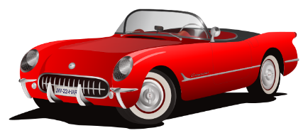

**Peacock’s Car Dealership**

14438 Werber Drive or 1 879-226-247

Great deals at the Peacock’s Grand Opening Sales Event

Get up to 30% off and 0% APR Financing on select models

Find us online at www.peacockcars.com

Hurry over, sale is limited time only!

Sales last until closing on 10/17

Alternative purchasing options available now!

We can help you get a loan

No one can beat our prices or our kind and friendly help staff!

We want you to be happy

Unlike other car dealerships, we value our customers, and want to help them find the car they want at the best price, without all the haggling

***“Peacock’s cars, we got cars!”***